A. Cover page (1 page)

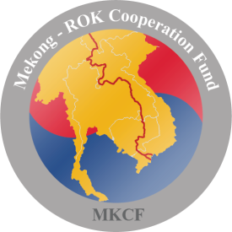 | Mekong-ROK Cooperation Fund (MKCF)  Project Concept Paper

1.1. Name and Address of Organization
1.2. Contact Person
- Name
- Telephone
- Fax
- email
1.3. Title of Proposed Project / Sector
1.4. Country(ies) / Region
1.5. Total Project Cost
1.6. Duration of Project
1.7.
- Signature of the proponent
- Name
- Title

B. Technical (3 pages maximum)
1.1. Introduction | Provide a brief background on the specific development challenge or opportunity the project will address.  Indicate the nature of the issue including description of the target population and its regional implication.
1.2. Objective | State the short and long-term objectives of the project and how objectives relate to specific challenges or opportunities in the specific sector in the country and the Mekong region.  Also explain how the project promotes cooperation between the Mekong countries and the ROK and contributes to the sustainable development of the Mekong region.
1.3. Description of Specific Activities | Provide the  1) method(s) of approach  2) brief description of the activities to achieve the stated objective(s)  3) how the regional challenges or opportunity will be addressed  4) potential partners in the Mekong region and role of the partners in the project.
1.4. Anticipated Results | Describe the expected outputs, outcomes and impact upon completion of the project.
1.5. Monitoring Framework | Provide indicative measures to monitor and evaluate the results of the project and how the results will benefit or be shared in the Mekong region.

C. Financial (2 pages maximum)
1.1. Financial Statement | Provide a brief statement as to why the proposed activities are feasible both technically and financially.
1.2. Estimated Cost | Provide an estimated budget (total cost), year wise (for multi-year project) and cost share.

D. Attachments
Any additional documents that provide information on past experience in implementing development projects, institutional capabilities and biography of the core project team.

The Fund provides grants to support catalytic and innovative activities in the six priority sectors: (1) Infrastructure, (2) Information Communication Technology (ICT), (3) Green Growth, (4) Water Resource Development, (5) Agriculture and Rural Development, (6) Human Resource Development.
Mekong region (Cambodia, Laos, Myanmar, Vietnam and Thailand)

