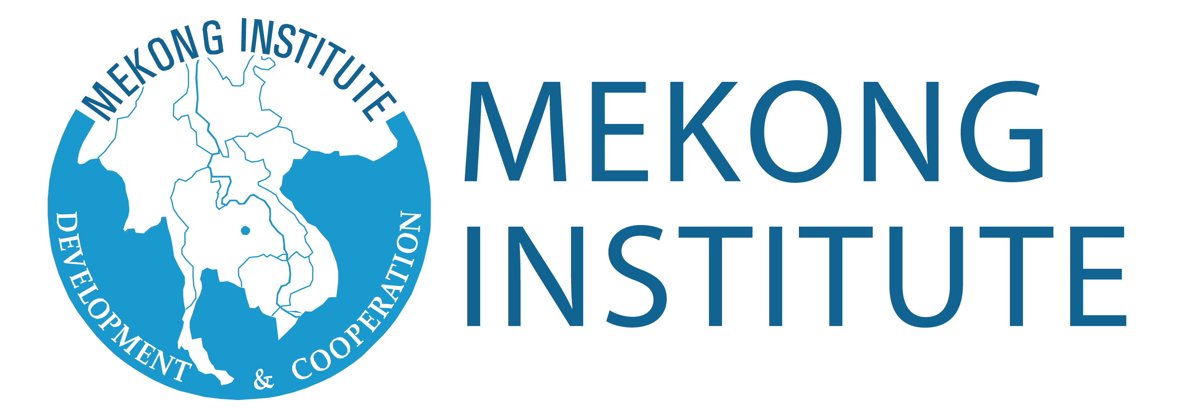
Promoting Safe Food for Everyone
Mekong Institute-Food Safety Project

APPLICATION FORM

Please fill in ALL SECTIONS of the application form and send it to Mekong Institute on or before the published deadline.
Training Program Title: __________________________________________
Dates: __________________________________________

PERSONAL INFORMATION
Full Name (As shown in passport): __________________________________________ Gender: [ ] Male [ ] Female
Birthdate (Month/Day/Year): ___________________ Nationality: _________________________________________
Passport/ID Number: ____________________________________________________________________________
Date of Issue (Month/Day/Year): ________________ Date of Expiry (Month/Day/Year): ____________________
Nearest International Airport: _______________________________________________________________________
Food Restriction(s) (if any): __________________________________________________________________________
Work Address: _____________________________________________________________________________________
City: _______________ Province/State: ____________________ Country: _______________________________
Home Address: : ___________________________________________________________________________________
City: _______________ Province/State: ____________________ Country: ________________________________
E-mail Address: _________________________________ Contact Numbers: _________________________________
Person to be Notified in Case of Emergency: _________________________________ Relationship: _____________
EDUCATIONAL BACKGROUND
Highest Educational Level Attained:
[ ] Vocational/Non-degree [ ] University Degree [ ] Advanced/Postgraduate Degree
Field of Study:
[ ] Natural Sciences [ ] Social Sciences [ ] Environmental Sciences [ ] Arts/Humanities [ ] Others: __________________
Address: _______________________________________ Contact Numbers: _________________________________

Name of University/School | Degree/Course | Years | Honors/Awards Received
Have you attended any program of Mekong Institute before? If yes, please specify: ____________________________________
__________________________________________________________________________________________________________

Have you attended any program of Mekong Institute before? If yes, please specify: ____________________________________
__________________________________________________________________________________________________________

Have you attended any program of Mekong Institute before? If yes, please specify: ____________________________________________________________________________________________________

Languages Used  (1 - Excellent; 3 - Good; 5 - Fair) | Reading Ability | Writing Ability | Speaking Ability
English | ① ② ③ ④ ⑤ | ① ② ③ ④ ⑤ | ① ② ③ ④ ⑤
 | ① ② ③ ④ ⑤ | ① ② ③ ④ ⑤ | ① ② ③ ④ ⑤
 | ① ② ③ ④ ⑤ | ① ② ③ ④ ⑤ | ① ② ③ ④ ⑤
PROFESSIONAL BACKGROUND
Title of Present or Most Recent Post: _____________________________________________________________________
Name of Organization: ___________________________________________ Years in the Organization: ______________
Type of Organization:
[ ] Government [ ] Private company [ ] Regional/International Organization [ ] Others ___________________
Office Address: ________________________________________________________________________________________
Contact Numbers: _______________________________________________ E-mail Address/Website: _______________
Description of work/responsibilities: _______________________________________________________________
____________________________________________________________________________________________
____________________________________________________________________________________________
Previous Employment
Position | Organization/Office | Years | Brief Description of Work Duties and Responsibilities

PROPOSED FOOD SAFETY STORY
Please briefly describe the local food safety story that you wish to work on after the training program. Describe how the regional training workshop will help you in developing and publishing/producing these stories.

CERTIFICATION
I certify that my statements in this application are true, complete, and correct.

If accepted for a learning program/workshop and/or scholarship, I will:
a. Carry out instructions and abide by conditions stipulated by the nominating government, scholarship sponsor, and Mekong Institute;
b. Follow the course learning schedule and abide by the rules of Mekong Institute;
c. Submit any progress reports, if requested;
d. Return to my home country promptly upon completion of the learning program/workshop; and
e. Not hold Mekong Institute responsible or liable for any act or occurrence reasonably outside of their control.

I also fully understand that to be granted this opportunity is an honor and privilege requiring the responsibility of dutifully representing my country and government.

Signature of Applicant over Printed Name: _______________________________________
Date: ______________________

Signature of Head of Organization over Printed Name: _______________________________________
Date: ______________________

For applications and other inquiries, kindly contact the following country coordinators:
- Cambodia: Mr. Ra Thorng (ra@mekonginstitute.org)
- Lao PDR: Mr. Alounmixay Keoboualapha (alounmixay@mekonginstitute.org)
- Myanmar: Ms. Jutamas Thongcharoen (jutamas@mekonginstitute.org)
- Vietnam: Mr. Dwight Jason Ronan (dwight@mekonginstitute.org)

MEKONG INSTITUTE
123 Khon Kaen University
Mittraphap Road, Muang District, Khon Kaen, 40002 Thailand
Tel: +66 43 202 411-2; Fax: + 66 43 343 131
Website: www.mekonginstitute.org

