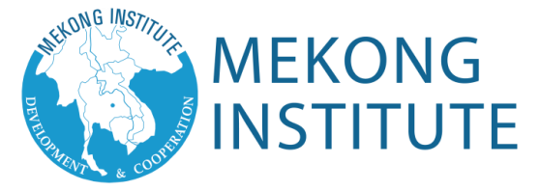

Photo

Photo

123, Mittraphap Road, Muang, Khon Kaen 40002 Thailand
Tel: +(66) 4320 2268 Fax: (+66) 4320 3656 Email: thantha@mekonginstitute.org
Website: www.mekonginstitute.org

APPLICATION FORM

Please fill in all sections of the application form and send it to Mekong Institute before July 24, 2017.

Training Program Title: Energy Cooperation in the Greater Mekong Subregion
Training Duration: August 7-18, 2017

Full Name (as shown in passport): .............................................................. Gender: M / F

Passport Number:..................... Date of Issue: ……………… Date of Expiry: …………
[DD/MM/YY]
[DD/MM/YY]

Date of Birth: ……….... Religion: ........................... Nationality: ………………………………
[DD/MM/YY]

Closest International Airport (Airport’s name and province): .................................................

Food Restriction (if any): .........................................................................................................

Work Mailing Address: ………………………………………………………………….………..
City : …………….………..Province/State: …………….…………...Country: …………….………..
Zip Code: …………….…..Office Telephone:…………….……….. Mobile:…………….………..
Fax: ………………………………….………..E-mail: …………….………..…………….………..
Home Mailing Address: ………………………………………………………………….………..
City : …………….………..Province/State: …….………….………..Country: …………….………..
Fax: ……………………………….….………..E-mail: …………….………..…………….………..
Name and Contact Details of person to be notified in case of emergency: ……..…………….…
Mobile:…………….……………………...….. E-mail: …………….………..…………….………..

Languages | Read |  |  | Write |  |  | Speak
Mother Tongue : | Excellent | Good | Fair | Excellent | Good | Fair | Excellent | Good | Fair
English
Other
[PLEASE SPECIFY]

Education History
Institution Name | City /  Country | Years  Attended |  | Degree, Diploma, Certificate, training courses completed | Special fields of  study
 |  | From | To
Have you attended any program of Mekong Institute before? If yes, please specify……………
………………………………………………………………….…………………..Year: ……………

Employment History
Present position: ……………  from: ………………to Present  [MM/YY]  Organization Type:……………  Ministry: ……………….………  Department: ……………….…  Division: ……………….…….. | Detailed description of your work duties and  responsibilities
Present position: ……………  from: ………………to …………  [MM/YY]  Organization Type:……………  Ministry: ……………….………  Department: ……………….…  Division: ……………….…….. | Detailed description of your work duties and  responsibilities
Expectations
Please write a short description of your expectations indicating the knowledge and skills you really need. Describe what professional development is required for you to improve in your work.

I certify that my statements in this application are true, complete and correct to the best of my knowledge and belief.
If accepted for a learning program/ workshop and/or scholarship, I will:
- carry out instructions and abide by conditions stipulated by the nominating government, scholarship sponsor and Mekong Institute.
- follow the course learning schedule and abide by the rules of Mekong Institute
- submit any progress reports which may be requested
- return to my home country promptly upon completion of the learning program/ workshop
- not hold Mekong Institute responsible or liable for any act or occurrence reasonably outside of their control
I also fully understand that to be granted a scholarship is an honor and privilege requiring the responsibility of dutifully representing my country and government.
Signature of Applicant over Printed name: ………………………………
Date: ………………………………

Signature of Head of Organization over Printed name: ………………………………
Date: …………………………………

