REGIONAL TRAINING PROGRAM ON
Managing Food Safety
Along the Food Supply Chain
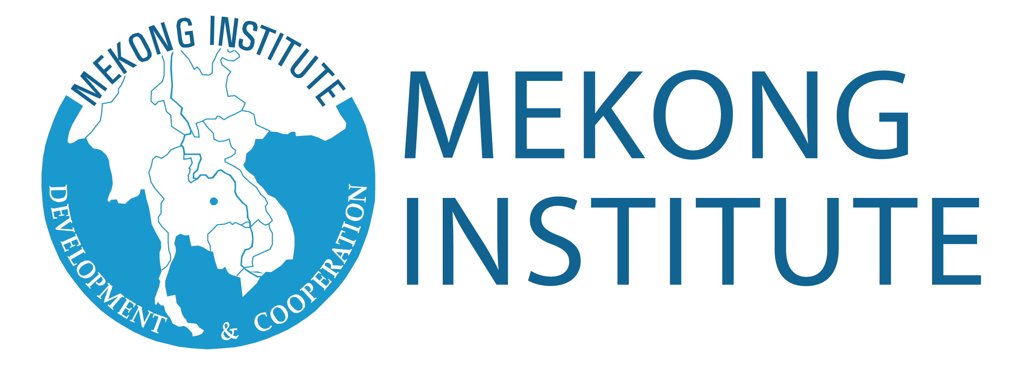

APPLICATION FORM

Please fill in ALL SECTIONS of the application form and send it to Mekong Institute on or before the published deadline.

PERSONAL INFORMATION
Full Name (As shown in passport): Gender: [ ] Male [ ] Female
Birthdate (Month/Day/Year): Nationality:
Passport Number:
Date of Issue (Month/Day/Year): Date of Expiry (Month/Day/Year):
Current Address:
Home Address:
E-mail Address:
Contact Numbers:
Food Restriction(s) (If any):
EDUCATIONAL BACKGROUND
Current Degree Program (Exact name of degree):
Current University:
Other Degrees Prior to Your Current Program:

Name of University/School | Degree/Course | Years | Honors/Awards Received

Have you attended any program of Mekong Institute before? If yes, please specify the course:

Languages Used | Reading Ability | Writing Ability | Speaking Ability
English | [ ] Poor [ ] Average  [ ] Good [ ] Fluent | [ ] Poor [ ] Average  [ ] Good [ ] Fluent | [ ] Poor [ ] Average  [ ] Good [ ] Fluent
 | [ ] Poor [ ] Average  [ ] Good [ ] Fluent | [ ] Poor [ ] Average  [ ] Good [ ] Fluent | [ ] Poor [ ] Average  [ ] Good [ ] Fluent
 | [ ] Poor [ ] Average  [ ] Good [ ] Fluent | [ ] Poor [ ] Average  [ ] Good [ ] Fluent | [ ] Poor [ ] Average  [ ] Good [ ] Fluent

PROFESSIONAL BACKGROUND
Title of Present or Most Recent Post:
Name of Organization: Years in the Organization:
Type of Organization: [ ] Government [ ] Private company [ ] Regional/International Organization [ ] Others
Contact Numbers: E-mail Address/Website:
Description of work/responsibilities:

Previous Employment:
Position | Organization/Office | Years | Brief Description of Work Duties and Responsibilities

Researches or Published Works:
Enumerate all published or ongoing researches, case studies, or other work related to food safety.
Title | Publication | Year | Abstract/Brief Summary

CERTIFICATION
I certify that my statements in this application are true, complete, and correct.

If accepted for this training program, I will:
a. Carry out instructions and abide by conditions stipulated by the nominating university and/or Mekong Institute;
b. Follow the course learning schedule and abide by the rules of Mekong Institute;
c. Submit any progress reports, if requested; and
e. Not hold Mekong Institute responsible or liable for any act or occurrence reasonably outside of their control.

I also fully understand that to be granted this opportunity is an honor and privilege requiring the responsibility of dutifully representing my country and university.

Signature of Applicant:
Date:

Signature of Adviser/Head of Department or Faculty:
Date:

For applications and other inquiries, kindly contact (dwight@mekonginstitute.org).

