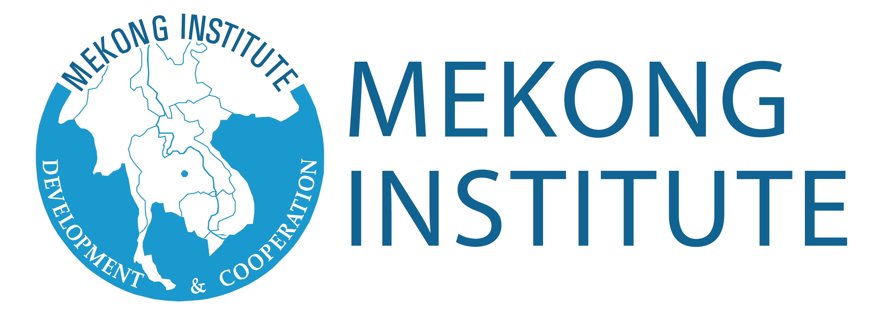
Promoting Safe Food for Everyone
Mekong Institute-Food Safety Project

APPLICATION FORM

Please fill in ALL SECTIONS of the application form and send it to Mekong Institute on or before the published deadline.
Training Program Title: __________________________________________
Dates: __________________________________________

PERSONAL INFORMATION
Full Name (As shown in passport): __________________________________________ Gender: [ ] Male [ ] Female
Birthdate (Month/Day/Year): ___________________ Nationality: _________________________________________
Passport/ID Number: ____________________________________________________________________________
Date of Issue (Month/Day/Year): ________________ Date of Expiry (Month/Day/Year): ____________________
Nearest International Airport: _______________________________________________________________________
Food Restriction(s) (if any): __________________________________________________________________________
Work Address: _____________________________________________________________________________________
City: _______________ Province/State: ____________________ Country: _______________________________
Home Address: : ___________________________________________________________________________________
City: _______________ Province/State: ____________________ Country: ________________________________
E-mail Address: _________________________________ Contact Numbers: _________________________________
Person to be Notified in Case of Emergency: _________________________________ Relationship: _____________
EDUCATIONAL BACKGROUND
Highest Educational Level Attained:
[ ] Vocational/Non-degree [ ] University Degree [ ] Advanced/Postgraduate Degree
Field of Study:
[ ] Natural Sciences [ ] Social Sciences [ ] Environmental Sciences [ ] Arts/Humanities [ ] Others: __________________
Address: _______________________________________ Contact Numbers: _________________________________

Name of University/School | Degree/Course | Years | Honors/Awards Received
Have you attended any program of Mekong Institute before? If yes, please specify: ____________________________________
__________________________________________________________________________________________________________

Have you attended any program of Mekong Institute before? If yes, please specify: ____________________________________
__________________________________________________________________________________________________________

Have you attended any program of Mekong Institute before? If yes, please specify: ____________________________________________________________________________________________________

Languages Used  (1 - Excellent; 3 - Good; 5 - Fair) | Reading Ability | Writing Ability | Speaking Ability
English | ① ② ③ ④ ⑤ | ① ② ③ ④ ⑤ | ① ② ③ ④ ⑤
 | ① ② ③ ④ ⑤ | ① ② ③ ④ ⑤ | ① ② ③ ④ ⑤
 | ① ② ③ ④ ⑤ | ① ② ③ ④ ⑤ | ① ② ③ ④ ⑤
PROFESSIONAL BACKGROUND
Title of Present or Most Recent Post: _____________________________________________________________________
Name of Organization: ___________________________________________ Years in the Organization: ______________
Type of Organization:
[ ] Government [ ] Private company [ ] Regional/International Organization [ ] Others ___________________
Office Address: ________________________________________________________________________________________
Contact Numbers: _______________________________________________ E-mail Address/Website: _______________
Description of work/responsibilities: _______________________________________________________________
____________________________________________________________________________________________
____________________________________________________________________________________________
Previous Employment
Position | Organization/Office | Years | Brief Description of Work Duties and Responsibilities

PROPOSED ACTION PLAN
Please briefly describe the action plan that you wish to implement upon your return to your home organization/country.

To utilize and demonstrate the knowledge and skills from the training program, I am going to:

CERTIFICATION
I certify that my statements in this application are true, complete, and correct.

If accepted for a learning program/workshop and/or scholarship, I will:
a. Carry out instructions and abide by conditions stipulated by the nominating government, scholarship sponsor, and Mekong Institute;
b. Follow the course learning schedule and abide by the rules of Mekong Institute;
c. Submit any progress reports, if requested;
d. Return to my home country promptly upon completion of the learning program/workshop; and
e. Not hold Mekong Institute responsible or liable for any act or occurrence reasonably outside of their control.

I also fully understand that to be granted this opportunity is an honor and privilege requiring the responsibility of dutifully representing my country and government.

Signature of Applicant over Printed Name: _______________________________________
Date: ______________________

Signature of Head of Organization over Printed Name: _______________________________________
Date: ______________________

For applications and other inquiries, kindly contact the following country coordinators:
- Cambodia: Mr. Ra Thorng (ra@mekonginstitute.org)
- Lao PDR: Mr. Alounmixay Keoboualapha (alounmixay@mekonginstitute.org)
- Myanmar: Ms. Jutamas Thongcharoen (jutamas@mekonginstitute.org)
- Vietnam: Mr. Dwight Jason Ronan (dwight@mekonginstitute.org)

MEKONG INSTITUTE
123 Khon Kaen University
Mittraphap Road, Muang District, Khon Kaen, 40002 Thailand
Tel: +66 43 202 411-2; Fax: + 66 43 343 131
Website: www.mekonginstitute.org

